**SETTING UP APPLICATION ENVIRONMENT**

**IBM CLOUD ACCOUNT**

|  |  |
| --- | --- |
| TEAM ID | PNT2022TMID51155 |
| PROJECT NAME | SMART FASHION RECOMMENDER APPLICATION |
| TEAM MEMBERS | M.karthik Muneeswaran , S.Gowtham Prabakar, M.Mohammed Sithik ,M.Muthukumar,R.Aswanth |

1. To create IBM academic initiative account, go to “ibm.com/academic”.

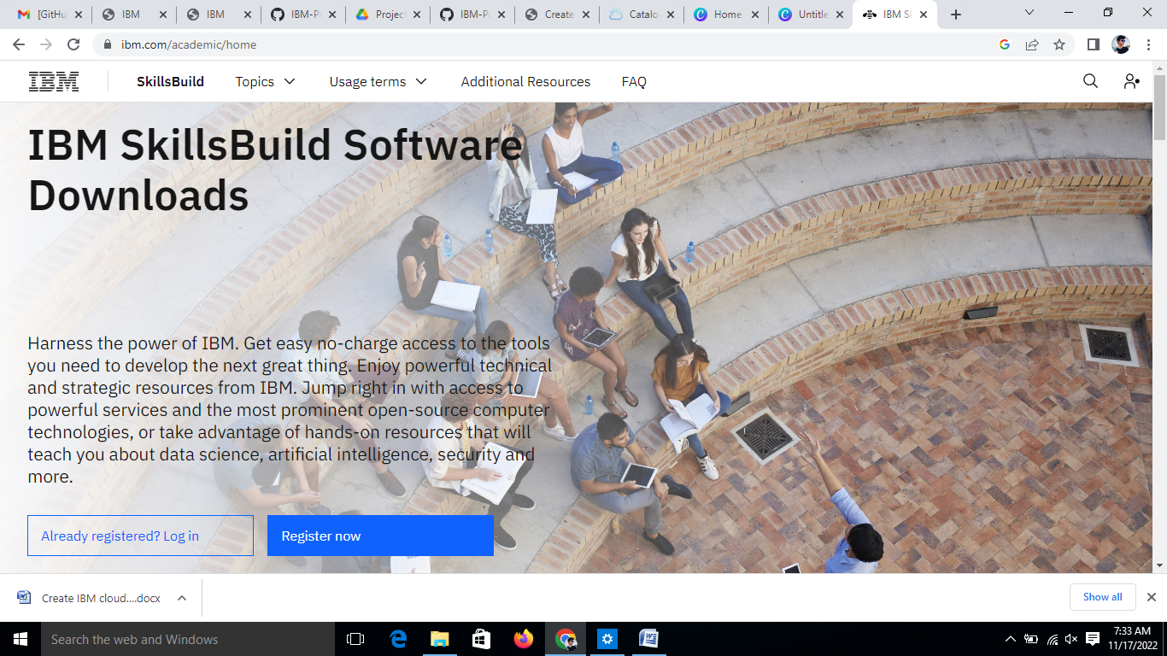

The page looks like the above

1. Click on register now and fill smartinternz email id from the profile section of ibm student account and fill in the form and click on register.
2. To sign up for ibm account, fill the account information, additional information and verify email from webmail (student login-webmail).
3. After OTP being entered, click on proceed, we will automatically be redirected to the belowpage,
4. Being redirected to ibm cloud home page, scroll doem and click on “IBM cloud-software- click on ibm feature code-request ibm feature code”. Copy the feature code and navigate to“cloud.ibm.com”.
5. Fill in the form details and after verification of email, check the box and then click on continue. Wait till the process being completed ie, account creation. Username being auto entered and enter password which is been created while the process of IBM initiative account.On next click on register with the code and copy the featured code and the account is created.
6. Now your IBM Cloud account is successfully created.
7. Then navigate to <https://cloud.ibm.com/>
8. Login with your credential
9. Now you use IBM Cloud Resources
10. The page looks like :

